1.UML diagram for Radio object – U1M2L1- HW submission date -20190605

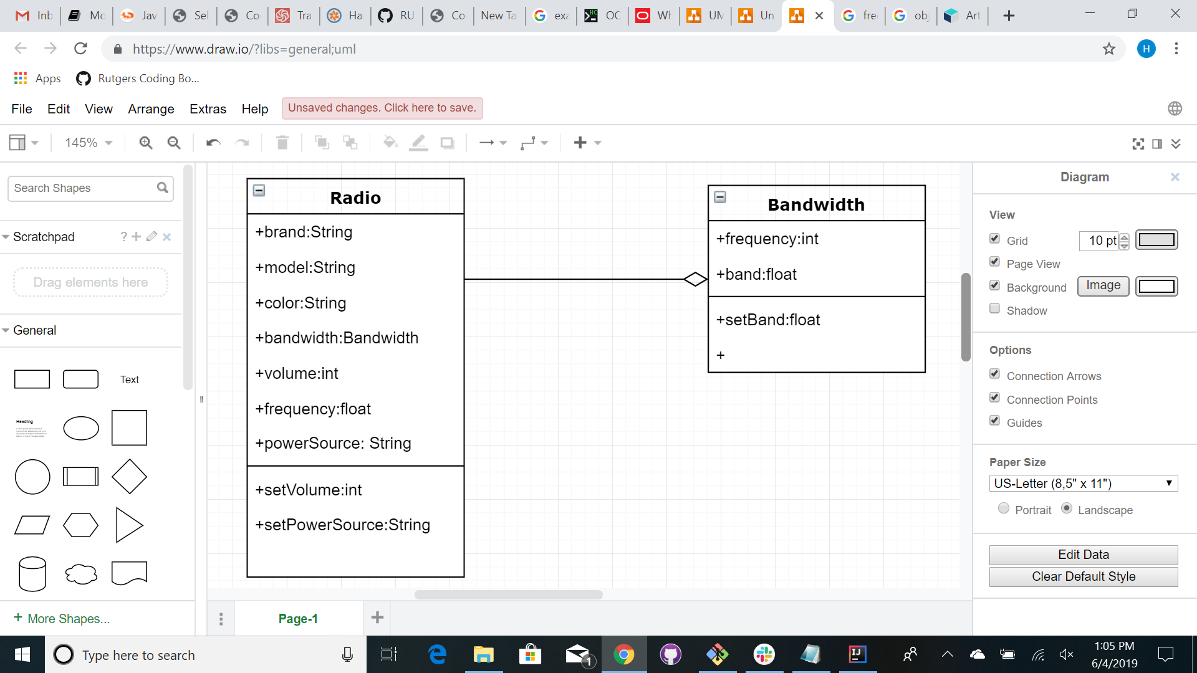

2.UML diagram for TV object – U1M2L1- HW submission date -20190605

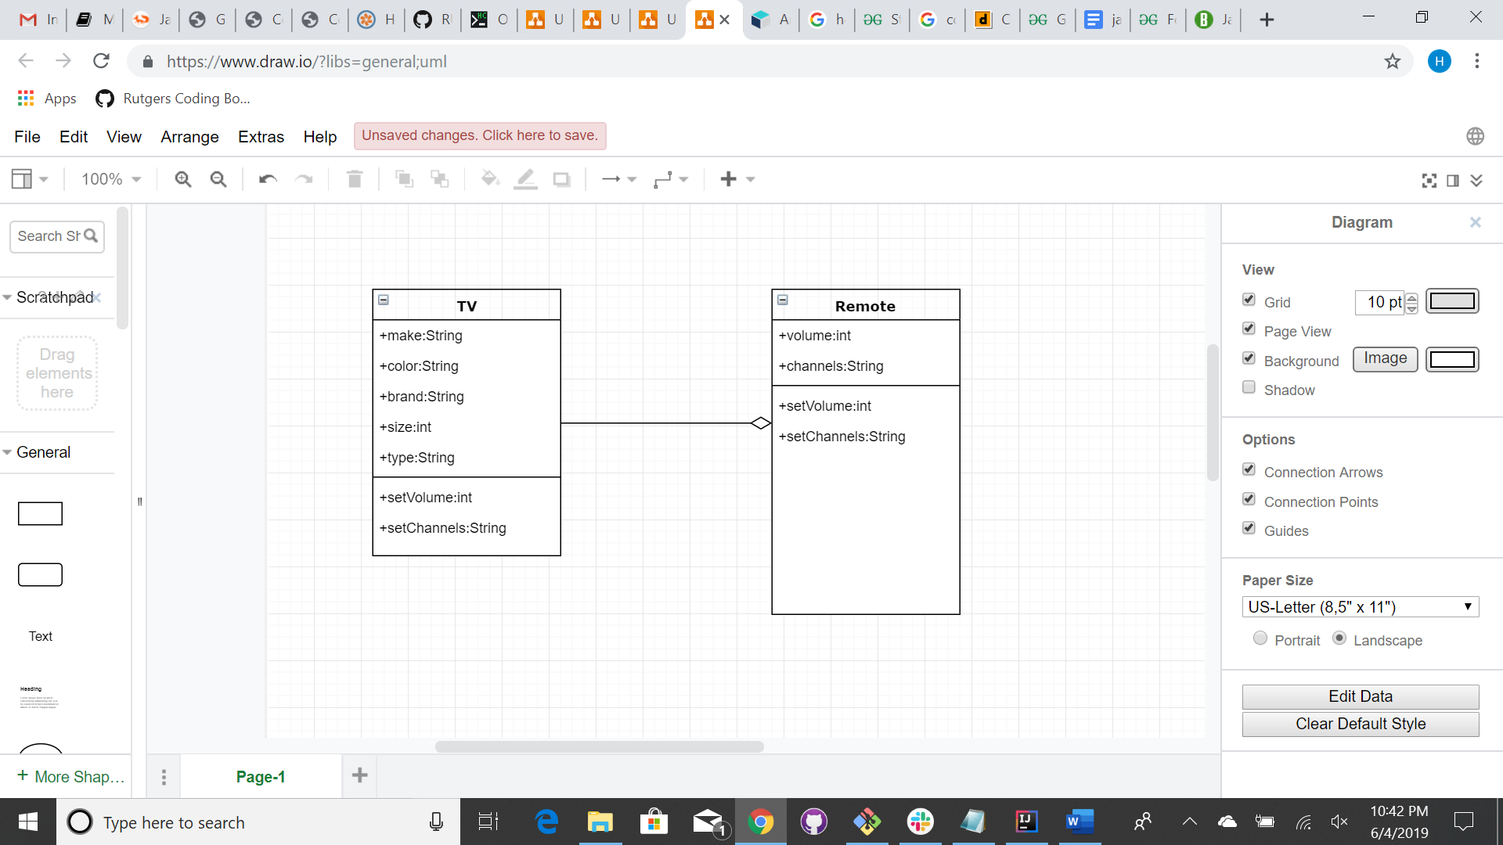

3.UML diagram for Car object – U1M2L1- HW submission date -20190605

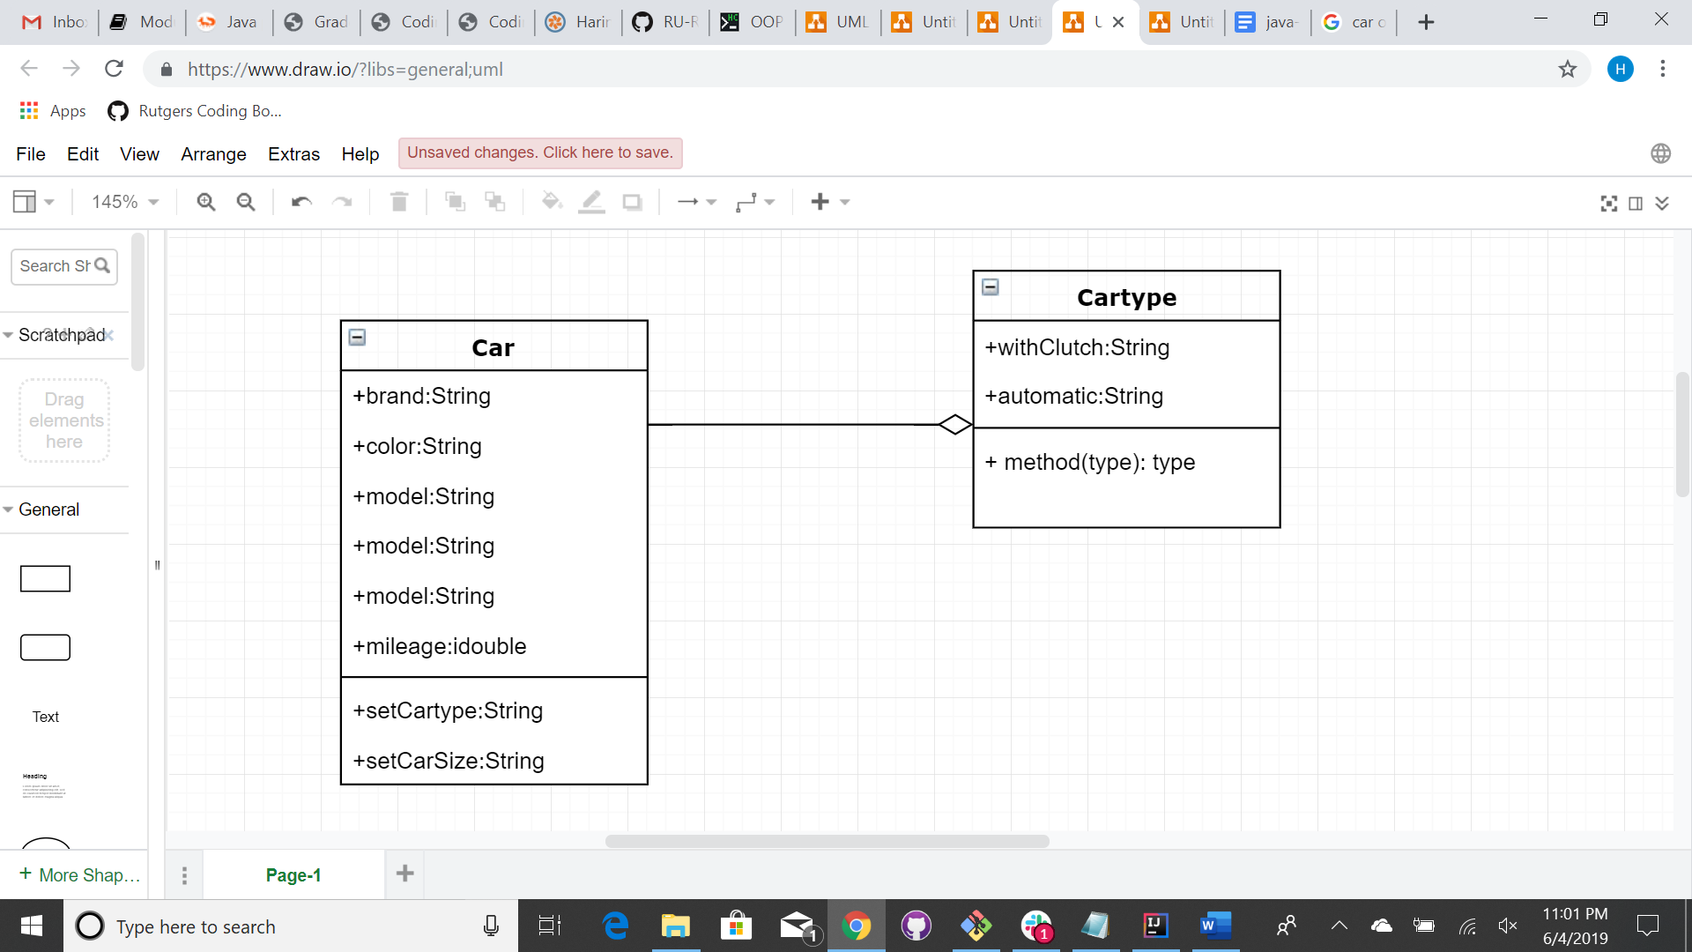

4.UML diagram for Computer Mouse object – U1M2L1- HW submission date -20190605

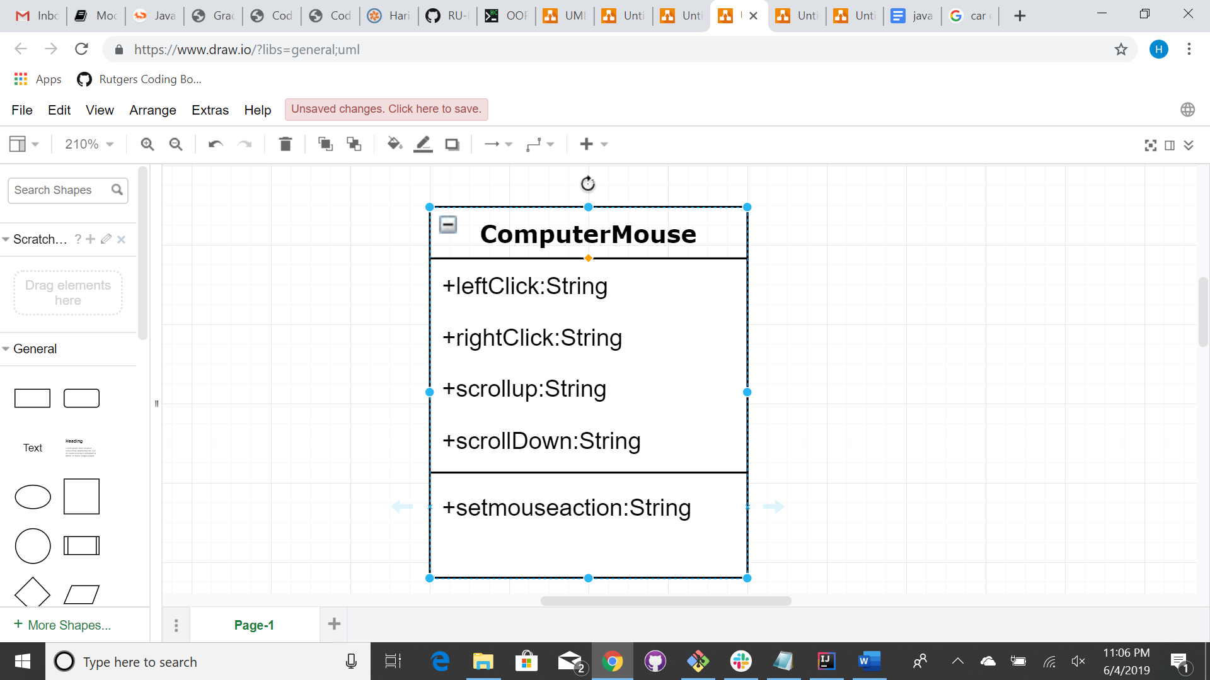

5.UML diagram for Coffee Maker object – U1M2L1- HW submission date -20190605

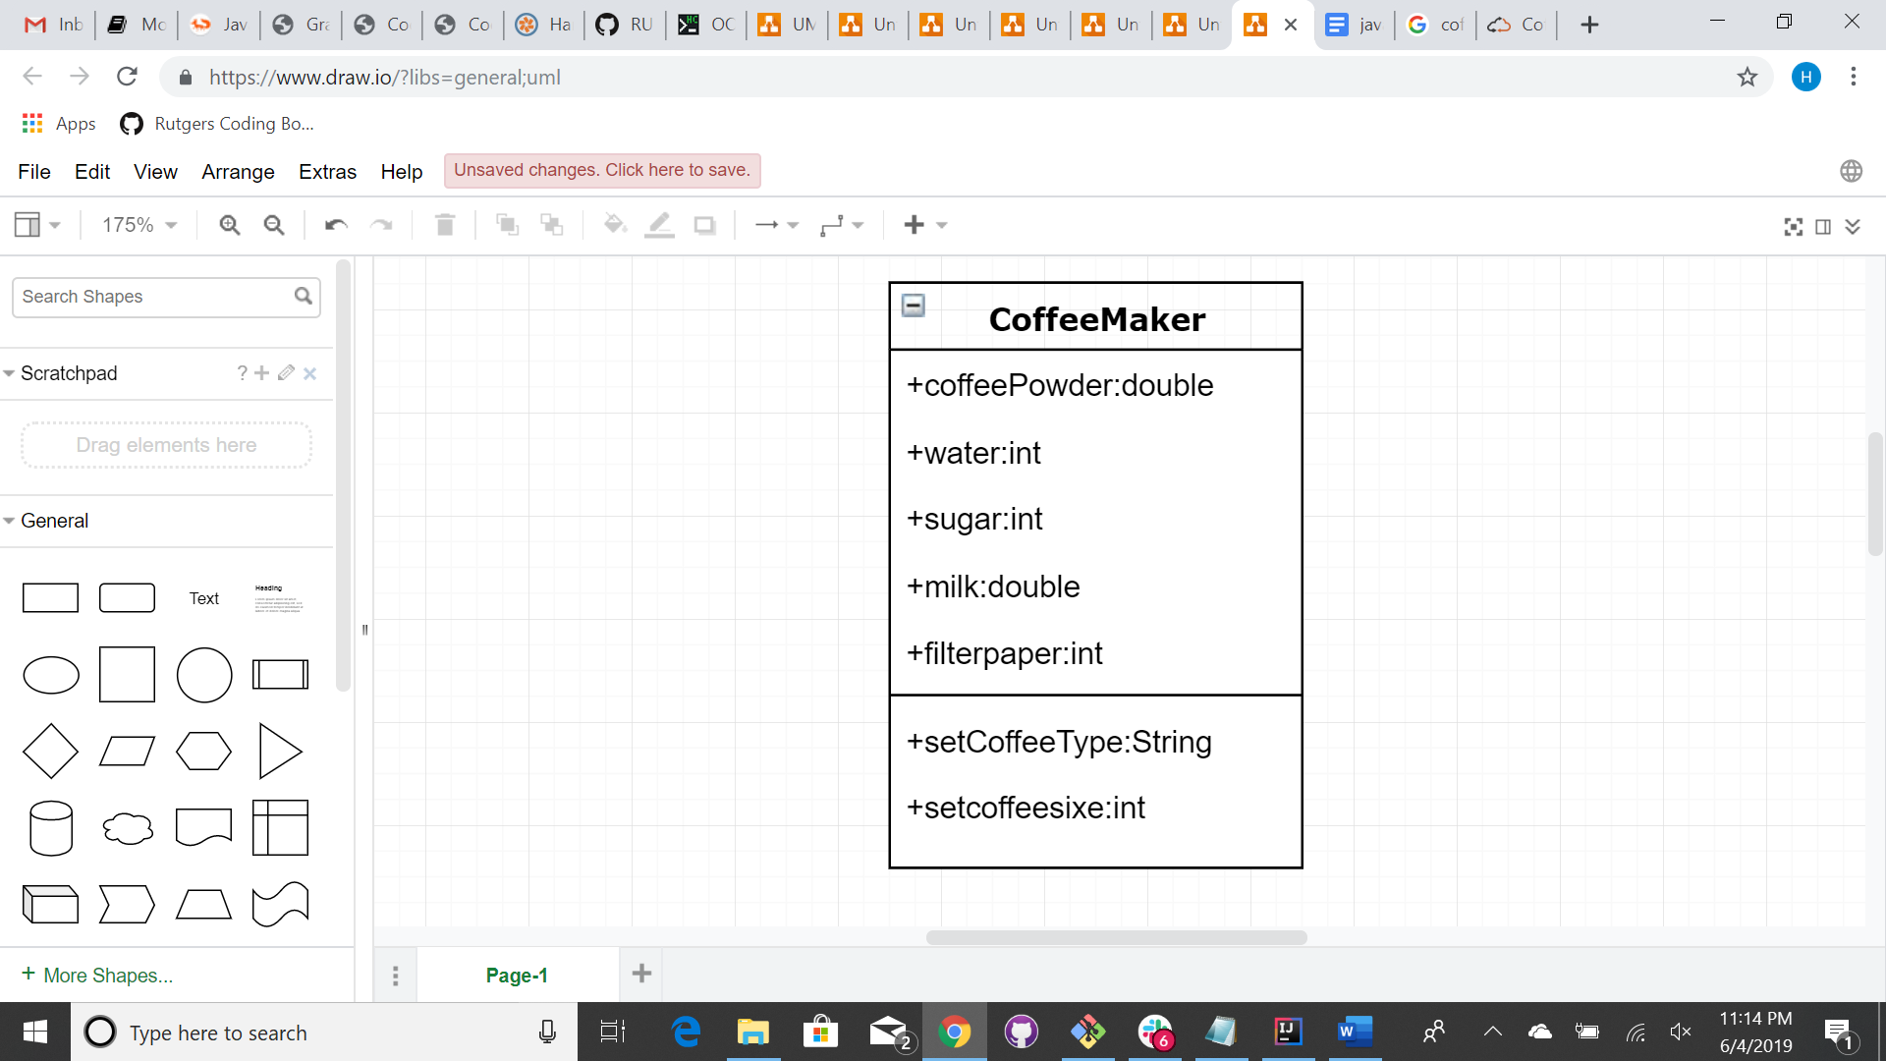

6.UML diagram for Microwave object – U1M2L1- HW submission date -20190605

